Dear Students!
As you know, the visits at chemical companies will take place during the week of 8 April. I have attached a group schedule and a schedule of the trips. In the case of MPK and BorsodChem, the buses leave from the learning center, opposite the DESOK (I attached a map).
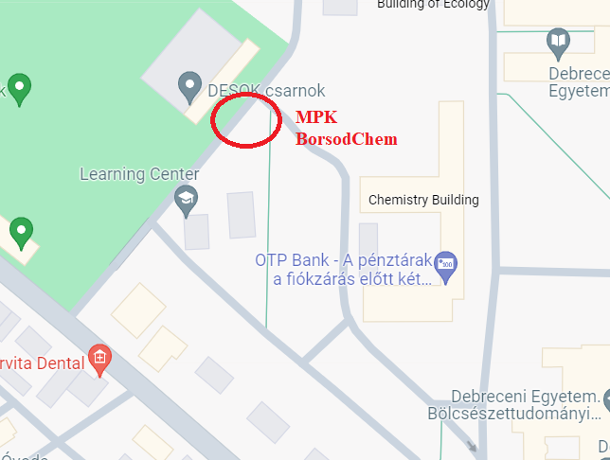
Departure times:
In case of MPK: 7:30 a.m. (expected arrival 16:00)
In case of BorsodChem: 6:30 a.m. (expected arrival 17:00)
The bus will not wait for those people who are late, so please arrive at least 15 minutes before the departure time.
In case of Teva Pharmaceutical Industries you must arrive at the company at 8:40 a.m. (bus was not ordered there, you must go there alone. You can go there either by walking or by DKV buses e.g. bus 13,).
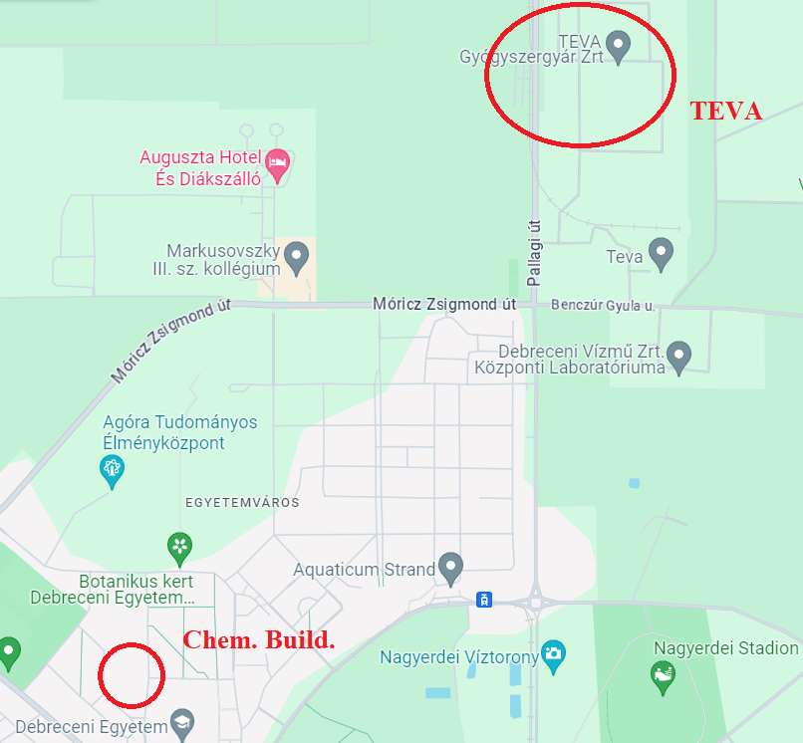
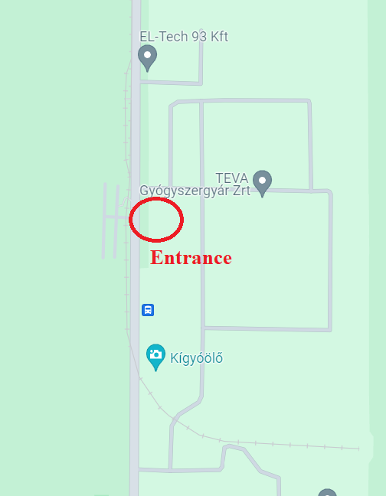 | 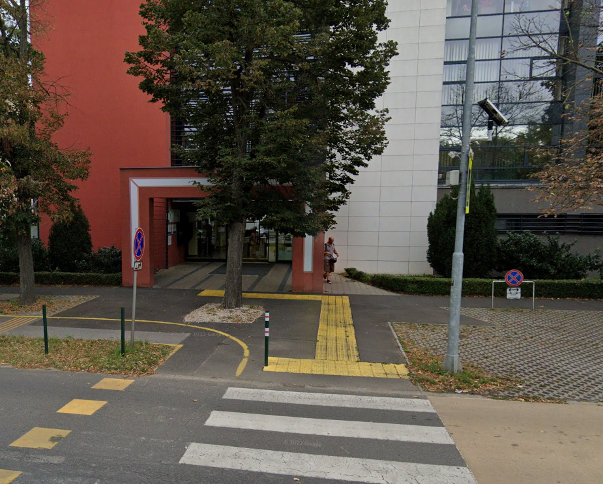

I would like to kindly ask you to bring your ID cards with yourself (passport as well), as the companies may ask for them at the entrance.
In addition, prepare sandwiches, snacks, and water for the trips,
Avoid drinking alcohol as you may be probed (randomly).

Taking part in the trips are mandatory!

